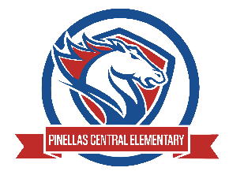

Pinellas Central Elementary School
PreK School Supply List 2025-2026

Abby Cannata, Principal Stephanie Wager, Asst. Principal
Student Items (for individual student use)
- full sized backpack-no rolling backpacks or mini backpacks
- extra change of clothes including underwear and socks in a large plastic zipper bag labeled with your child's name
- small blanket and a standard fitted (the ones with elastic corners) crib size sheet for the cot for rest time.
- reusable shopping bag, labeled with child's name - used for cot sheets
- refillable sports bottle with your child's name on it
- clearview 1 inch 3 ring binder (clear pocket on front of binder)
Supplemental Classroom Items

- paper towels
- tissues
- baby wipes
- hand sanitizer
- disinfecting wipes
- dry erase markers
- zip top bag - sandwich, quart, gallon
- 3 oz paper cups
- paper plates - please no Styrofoam
- paper bowls - please no styrofoam
- healthy items for snack time: pretzels, goldfish crackers, raisins, graham crackers, and animal crackers.

Wish List Items
- play-dough
- craft supplies - googly eyes, pipe cleaners, beads, pom poms, etc.

